Our clay based greens are OK but the surrounds are old fashioned, difficult to maintain and hold water or encourage it onto the playing surfaces!

Many golf clubs have an easy, albeit, disruptive and expensive decision to make if their clay based greens are beyond their sell by date – re-build them to as good a specification as possible.

Normally, the surrounds, including the greenside bunkers, would also be re-built but what happens if, through good management, and annual maintenance techniques your putting surfaces are acceptable and you do not want the disruption or the expense of re-building all your greens?

The answer - re-shape your surrounds.

In our experience many clubs have greens which provide reasonable putting surfaces, but, more importantly, the shapes and contours are known and liked, so why disrupt them. The introduction of just one USGA specification green into a mix of clay greens is difficult and matching quality and playability is often impossible.

We have found that many of the problems with greens lie in the surrounds where there a number of likely issues;

They are

- Featureless
- Attract water from surrounding areas onto the putting surfaces
- Feature greenside bunkers without any shape, form or style – no consistency
- Do not have defined entrances to the greens
- Invariably have the fairway running directly to the green edge with no approach or collar
- Are bumpy, too steep, have high unmaintainable ridges around the rear and are, essentially, difficult to manage efficiently using modern equipment

There are four important issues where we feel that re-shaping surrounds can be the answer

- Playability and strategy
- Ease of maintenance – access for machinery
- Management of surface water around the playing surfaces
- Control of traffic circulation

Playability and strategy

By altering the surrounds and hazards around a green one can create a strategic approach to the game rather than none.

How many old (and not so old) courses feature a wide approach to the putting surface with hazards right and left?

Who does this penalise and what does it promote?

Answer = players offline and promotes only the straight approach to the green.

By adding offset penal greenside bunkers perhaps to the green front RHS with a swale (a wide valley) on the left hand side one immediately promotes a more strategic approach where players would soon learn to position their drives to the RHS of the fairway to get a better approach into the green.

This then leads onto accurate positioning for fairway hazards and thus the hole is achieving some shape and strategy - easy isn’t it.

When you apply this to the many vagaries and natural features within a golf course the whole thing gets quite complicated and that is why golf architects should be appointed.

Ease of maintenance

If your course has examples of quirky mounds or pimples, steep banks, difficult junctions with hard surfaces or against walls, your maintenance will take far longer than necessary. The greenstaff nowadays have little time to keep the course looking pristine as they are constantly interrupted by golfers who naturally want the course looking pristine! You can tell my father was a Head Greenkeeper!

If surrounds are well thought out they can be managed easily and swiftly, leaving more time for the greenstaff to manage and present the more important fine turf areas.

The features/hazards within the surrounds should dictate the presentation of the green and we feel it is important that a good collar and approach is developed.

Many courses display a fairway maintenance regime running right up to the green front. The is an area which will have concentrated compaction in any case so why turn the fairway cutting equipment at this point rather than 10m away down the fairway?

Golfers too will also treat this area like fairway if the maintenance is the same standard as the fairway. We prefer to see a highly managed and well presented approach to the same standard as the collar at the front of the green. This then tells the players to treat this area with some more respect and will also allow a better variety of shot making from this position.

Back to the general surrounds: why should greens still feature a raised bank at the rear or to the side of the putting surface which is ugly and difficult to manage? These things are easy to remove but if you are bringing a machine in to do some work then why not add a bit of flair while you are at it.

One must start to think in 3D and that is not easily for the untrained, do not just think about mounding above ground for the surrounds. What about the creation of wide excavations below ground to create grassy hollows and swales which can transform a green?

We have experience of simple clay based greens built at the same level as the approaching fairway with flat bunkers positioned with no relationship to the green.

Forgetting the bunkers at this stage, by creating a wide swale around the surrounds of the green apart from a narrow approach, suddenly this hole is transformed. One could be excused for thinking that the green has been elevated but it is the relationship with the surrounds which has changed. (Only possible if you have a good positive drainage outlet)

Management of surface water around the playing surfaces

This brings us to the management of surface water. Clearly not many golf courses have software capable of telling them exactly where the surface water will run dependant upon the contouring around the green. We do and with an accurate topographical survey we can easily determine any problems in this area.

Golf courses are generally not created on totally flat ground, therefore, surface water will run across them. Playing surfaces in general should never have the surrounding surface water directed onto or near them. This is important in all cases but even more important where you have clay based greens as the green will act like a sump and ultimately fill with water.

This is a problem that we see time and time again where the surface water either runs onto the putting surface or even into one of the bunkers. A proper understanding of the shaping of the surrounds will prevent this problem, however, we also can prove that by attending to this issue, and introducing swales and other features the aesthetics, playability, maintenance and drainage can all be improved in one operation which does not have to disrupt the putting surfaces. Naturally proper land drainage and outfalls must also be employed during these works.
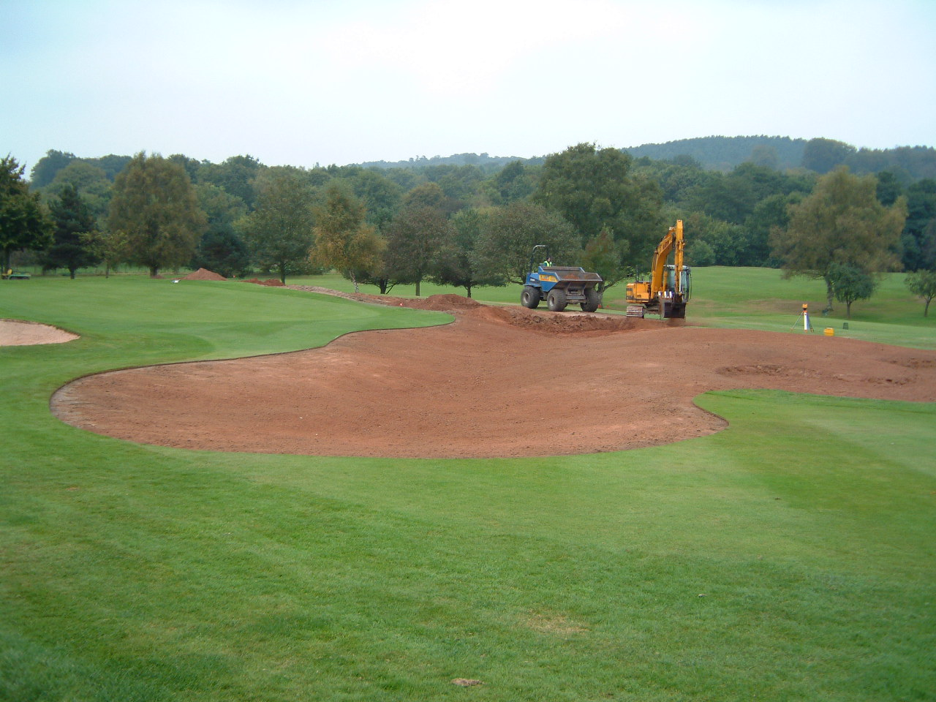
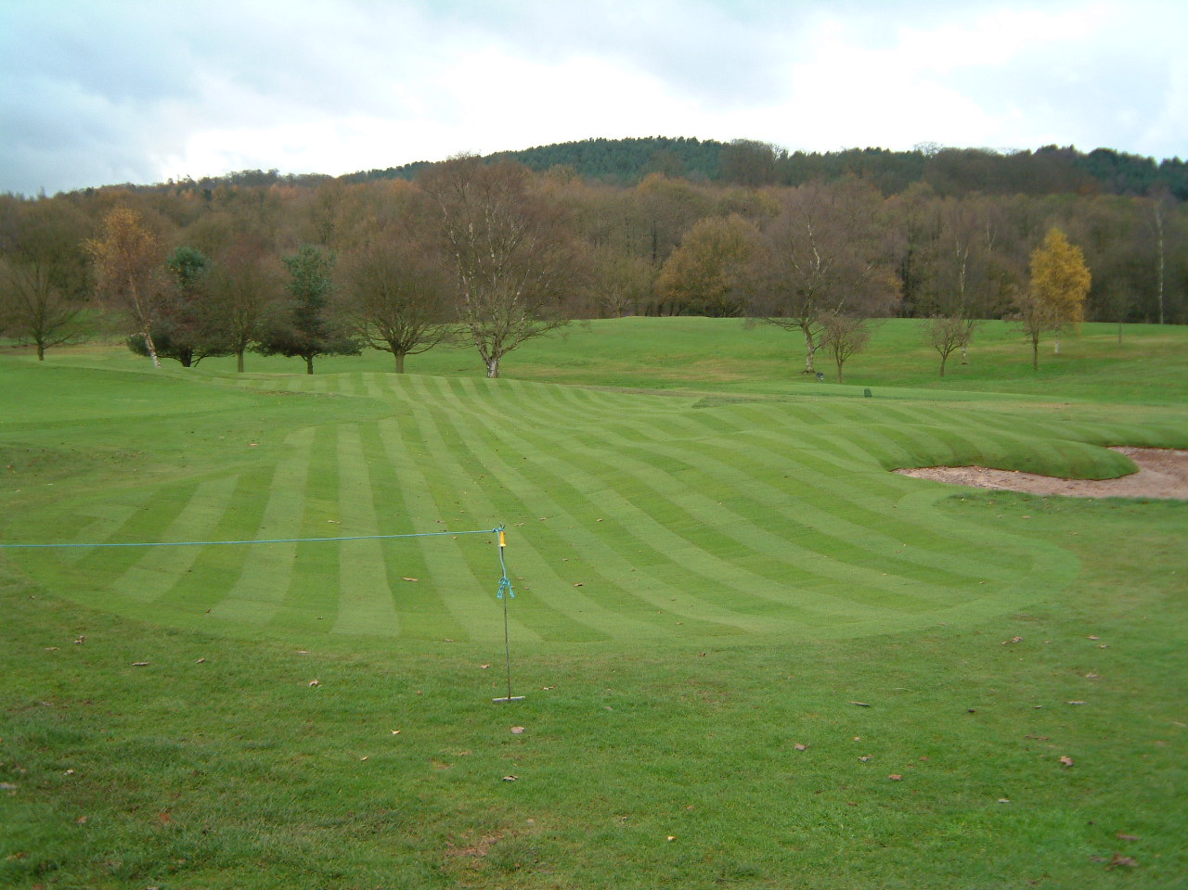
Control of circulation

The circulation of golfers around the greens can create problems. Essentially players walk in what we call ‘desire lines’ i.e. they take the shortest route from A – B.

There are a number of desire lines around the course which some people often forget, those being from tee to fairway to green and from greens to tees and finally from the 18th green to the bar!

This sounds obvious but how many times do you find a bunker or other obstacle directly en route from the green to the next tee. The result will be either one or two eroded and bare areas either side of the offending bunker leading to the next tee.

This then comes down to the design of the surrounds and positioning of the hazards.

As a general rule there should be no hazard in this desire line and the route should be around 5m wide to spread the wear and tear to cater for ‘walk-on’ walk-off’ areas.

So how do you go about re-shaping your surrounds?

Firstly employ a golf architect, experienced in this type of work, who should advise that you need an accurate site survey so that drawings ca be produced and drainage studies carried out accurately. If this is not possible then a more hands on approach would be required but normally the additional time on site can be as costly as a good survey which we feel is an investment for any club.

The topographical survey not only gives a 3D impression of the site it also contains accurate 2D information so that the green keeper can tell at a click of a button what the green, tee or fairway areas are, for example. All irrigation lines and drains would also be shown so that blind trial digging for pipework should be a thing of the past. Furthermore, once the 3 dimensional data is collected we would be able to produce a complete surface water diagram of the whole course – the first stage to realising where the problems lie in drainage and where best to install new drains.

That being done the drawings illustrating the surrounds reshaping work need not be that complicated and in some cases should be left flexible to allow adaptation and refinement of the works on site. This also should come with a very good architect/contractor relationship and it is ESSENTIAL that the shaper knows the architect very well (having worked with him before) and completely understand what is being achieved.

As far as the cost goes, the shaping of the surrounds can be far cheaper than green reconstruction and is certainly quicker and less disruptive. (weather dependant)
A green reconstruction can be anything from £12 -25,000 each whilst surround re-shaping can range from much less £2,500 – 7,500 (dependant on scale, number of bunkers etc) as it does not involve the materials for the greens reconstruction and the greenstaff can easily get involved particularly by lifting and re-laying turf. The only additional expense, apart from the machine work, will be the drainage pipe and materials and perhaps some good dry topsoil for preparation and the laying and purchase of turf, if required. Fewer materials moved across the course should mean less disruption and if you are able to re-use existing turf in places all the better for cost saving.

We have recently completed works at several courses where bunkering and surrounds reshaping has been carried out. One two particular contracts, Trentham Park GC and Bath GC the secretaries had to do some background research to find out exactly what a ‘swale’ was and what it meant. We golf architects often talk about these things and presume that golfers understand what we mean, wrongly so. By incorporating swales with bunker re-design and general surrounds reshaping many of the greens at Trentham Park have been completely altered improving their appearance and playability and also promoting more strategic thought when playing the hole and approaching the green.

Quote by Trentham/Bath GC

Quote by Abbots/A B Contractors

Steve Marnoch
Monday, 12 May 2003

